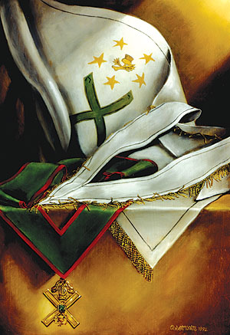
Twenty-ninth Degree
Knight of Saint Andrew

Jim Tresner, 33°, Grand Cross

Photo: Oil painting by Bro. Robert H. White, 32°

The X-shaped cross is the primary symbol of this Degree. The jewel of the Degree is a large St. Andrew’s cross* in gold, with a Knight’s helmet above and a thistle below. In the center of the cross is a large emerald. The emerald signifies the manly virtues and strength (by its color) as well as purity (by the clarity of the stone). Both the thistle and the St. Andrew’s cross have become symbols of Scotland.
The collar is green, edged with crimson, with the jewel hanging from the point. The regalia also includes a white cordon or scarf, fringed with gold and worn from left to right. In these two pieces of regalia, we have again the colors red, white, and green which are so significant in the Scottish Rite.
It is interesting to note that this is one of the few Degrees for which Pike describes a banner (and the banner, of course, plays a role in the theatre of the Degree). It is white, with a St. Andrew’s cross on green. On the ends of the arms of the cross are the four Hebrew letters, which spell the name of Deity. Above the cross is a circle formed of five gold stars with five points. Inside the circle is a golden thistle.
The cross of St. Andrew is an ancient symbol, far older than Christianity. It is formed in the heavens by the point at which the celestial equator crosses the plane of the ecliptic. Seeming to have symbolized the idea of change from very early times, it appears on ancient statues of the Mithraic deity Kronos, the lion-headed, winged human figure often shown standing on a globe marked with that cross, probably suggesting change as a function of time.
In many ways, change is the theme of this Degree. The Can-didate undergoes several changes and reverses in the action of the Degree, before coming at last to his reward. He appears suddenly before the Inquisition—the very type and image of religious intolerance and a reminder to all that intolerance in any form and from any source is tyranny. It is only when he proves faithful to his trust that the illusion dissolves and he discovers he is not in the hands of the Inquisition but of his friends.
His world changes again when he is left to guard the banner and is attacked. And it changes yet again when he is instructed in the nine great excellencies of a Knight of St. Andrew. The three excellent qualities are humility, patience, and self-denial. The three more excellent qualities of a knight are charity, clemency, and generosity. The three most excellent qualities of a knight are virtue, truth, and honor.
The Degree ends with passages of sheer beauty, some of the most lovely language of the Rite, as Pike shows that heroic figures of the past have much to tell us and that their teachings are echoed and seconded in the natural world around us.
And so the Knight is now armed with the excellent qualities he has learned from the great examples of humanity who have gone before. His character has been proved, and he has been trained (27°) in the arts of combat. It is now time to learn the identity of the enemy.

*The St. Andrew’s Cross (Cross Saltier, Crux Decussata) forms the jewel of the 29°, Knight of St. Andrew. The cross of this shape has many Masonic associations. It is represented upon the Celestial Sphere of the Fellow Craft Degree as the point at which the plane of the ecliptic crosses the celestial equator. Plato taught that it marked the spot of the creation of the universe. It is thus a symbol of change or transformation, and it is as this that it appears in the prophetic casting of lots, which we have come to know as the children’s game, Tic Tac Toe. In the original casting ritual, the X represented change and transition while the O represented permanence and stability. It also symbolizes the intersection or interaction of the material with the spiritual. In making the Sign of the Good Shepherd, the arms form a St. Andrew’s Cross, used as the position of prayer in the Scottish Rite. The major symbol of the 29°, it also appears in the camp symbol of the 32°, were its crossing marks the location of the Grand Commander. In many of the Degrees from the 6° onward, a St. Andrew’s Cross is formed by crossed swords.
The Scottish Rite Journal - August 1997

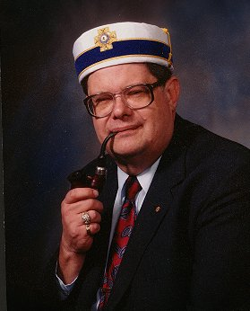
Jim Tresner
is Director of the Masonic Leadership Institute and Editor of The Oklahoma Mason. A frequent contributor to the Scottish Rite Journal and its book review editor, Illustrious Brother Tresner is also a volunteer writer for The Oklahoma Scottish Rite Mason and a video script consultant for the National Masonic Renewal Committee. He is the Director of the Thirty-third Degree Conferral Team and Director of Work at the Guthrie Scottish Rite Temple in Guthrie, Oklahoma, as well as a life member of the Scottish Rite Research Society, author of the popular anecdotal biography Albert Pike, The Man Beyond the Monument, and a member of the steering committee of the Masonic Information Center. Ill. Tresner was awarded the Grand Cross, the Scottish Rite's highest honor, during the Supreme Council's October 1997 Biennial Session

